Pop and Eco Study Guide Inv. 7
Your Name: _____________________________________________
Parent Signature____________________________ (Or AC LAB teacher)
Quiz Date: _______________________
This document needs to be signed in order to be eligible for test corrections if needed. I want to support your learning AND make sure you’re preparing the first time.

Check off the bullet points as you complete them to prepare for your quiz. You should do a minimum of 3 before asking for a signature from a guardian or Ac Lab teacher.
- ____ Practice vocabulary words. (VERY IMPORTANT!)
- ____ Reread science articles - Your teacher has copies if you need them.
- ____ Make sure all your work from investigation 7 is complete.
- ____If you were absent, be sure you read through the lab activities, so you know what you missed!
- ____ Ask your teacher questions about any of the topics that have you puzzled. Advocate for your learning…. Seek understanding
- ____ Answer the following practice questions—

1) Describe the difference between an introduced species, invasive species and native species. ________________________________________________________________________________________________________________________________________________________________________________________________________________________
2) Describe how an invasive species may affect the abiotic part of an ecosystem.

3) Describe how an invasive species may affect a biotic part of an ecosystem.
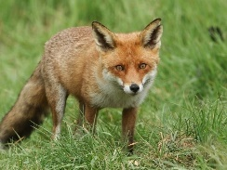
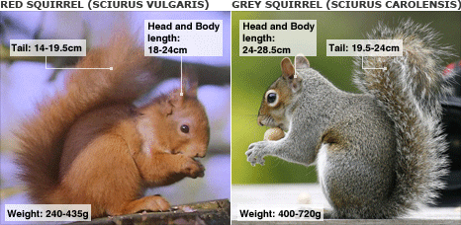
Two students looked at the data about how the red squirrel populations changed over time. Each made a claim about a cause-and-effect relationship.
Student A: An increase of the fox population caused the red squirrel population to decline.
Student B: An increase of the gray squirrel population caused the red squirrel population to decline.
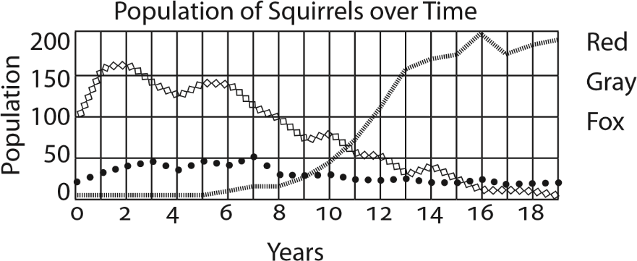
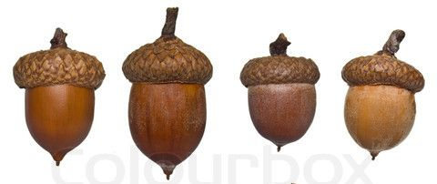

Which student do you agree with most? ____________ Describe the evidence that supports this claim.

What would happen to the fox population if the oak trees didn’t produce any acorns due to an especially dry growing season?
What other things could be a limiting factor for the grey squirrel? Name as many as you can and tell me if they are abiotic or biotic.

