1.1 Day Two Push and Pull

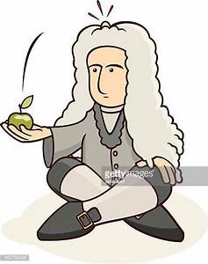
Name: ____________________________________Section: ______________
We will look at the cause and effect relationships with motion

