1.1 Day Three Push and Pull
Name: _____________________________________ Section: _______________
We will look at the ways forces can be combined or cancelled and begin to explore friction.

Add to your vocabulary page please:
Kinetic energy: Energy of motion 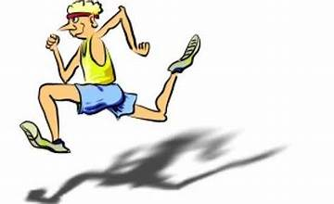
Directions for activity:
Today you will be using cars that can be hooked to the spring scale using a paper clip to measure pulls. Make sure you predict before you apply the force!

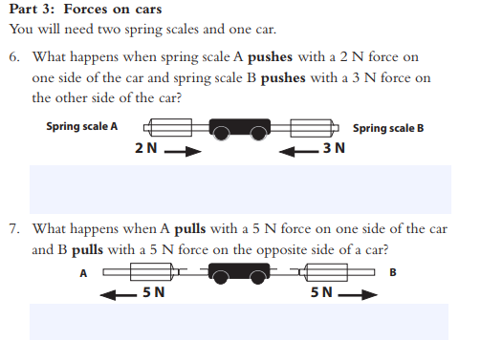
2
1
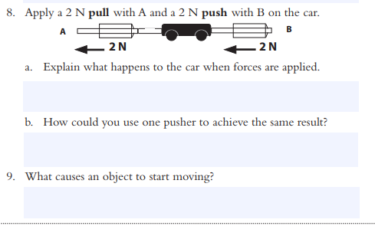
4
3
Please return your cars and spring scales before filling out the chart with your teacher below.

5. Let’s use this chart to summarize our learning from Activity C.
Activity | Cause and Effect | Explanation
Pushes and Pull C | - When two forces are pushing on an object, it will move in the direction of the push with the _____________force.  - When equal forces are pushing on opposite sides, the object______________________.  - If you pull on one side and push on the other, it’s the same as pushing or pulling with the combined force. | - An object will start to move if a force is exerted on it.  - Two equal forces pushing on an object cancel each other out.  - Two forces (a push and a pull) moving in the same direction add together.

6. Why didn’t the loads move when the force applied to one side was small?
________________________________________________________________________________________________________________________________________________________________________________________________________________________________________________________________________________________________________________________
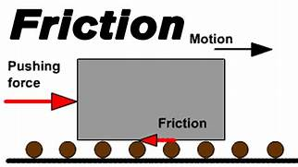
7. Friction is a force between two surfaces that resists movement. When you pushed or pulled too lightly, you didn’t use enough force to overcome the force of friction. Therefore, the object didn’t move. Please add the underlined definition to your vocabulary sheet and draw a picture to show your understanding.

8. Net force is the sum of all forces acting on a mass. Please add to your vocab page as well.

