1.1 Day Two Push and Pull
Name: ____________________________________Section: ______________
We will look at the cause and effect relationships with motion as we pull objects and measure the amount of newton’s necessary to do so.

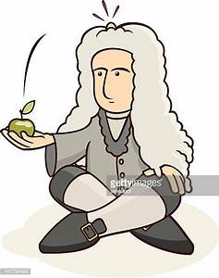

Let’s start by looking at some of our discoveries from yesterday.
Activity | Cause and Effect | Explanation
Spring- Scale Exploration | - Larger objects require _____ more force to move.  - Two or more spring scales together can apply enough force to move an object that can’t be moved by one.  - Different surfaces require ___________ amounts of force to move an object. | - It takes more force to move a larger, heavier object.  - A push can involve more than one force.  - The surface affects the amount of force needed to move an object.

We are going to use the springs scales to a push or PULL a load today. A load is the total mass you are trying to move. The more loads you pull; the more mass you are moving. You will be banding the loads together so it moves as one and pulling the load across a mat so it moves on a uniform surface. You will want to pull the loads slowly and evenly to get an accurate reading of the force. Remember that to find the average of a set of data you will add up the trials and then divide by the number of trials (in this case 3.) Trial 1 + Trial 2 + Trial 3 = total/3
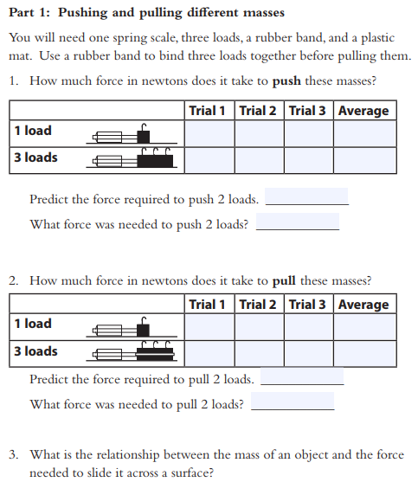

4. You have been measuring in newton’s or N for short. A newton is the metric unit for force. It takes 1 newton to move 1 kg 1m/s2. Please add this definition to your vocabulary sheet.
5. Use your data to complete the cause and effect chart below:
Activity | Cause and Effect | Explanation
- Pushes and Pulls A | - It takes ____N to push 1 load and _____N to push 3 Loads.  - It takes ___N to push 1 load and ___ N to pull one load. | - The ________ the mass, the more force is needed to move it.  - The pulling force and the pushing fore is _____________  To move a mass.

For the next activity you will need to pair up with another group of two because it requires 2 spring scales. As you work, consider the questions carefully and be ready to discuss them as a whole group.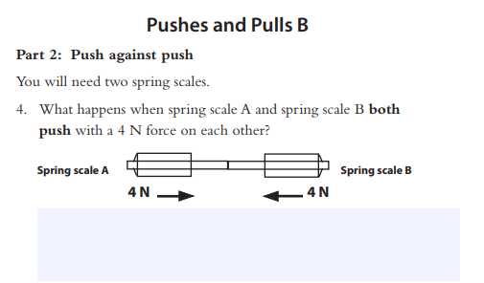
6.

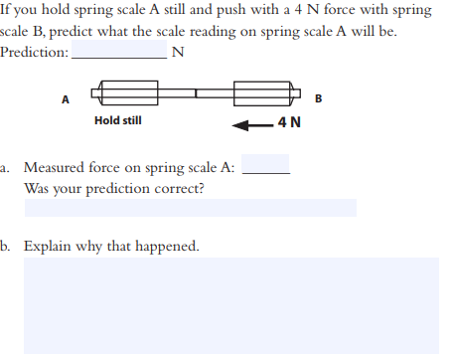
7
Important:
This is evidence of one of Newton’s Third Law of Motion which states, “For every action there is an equal and opposite reaction. If time allows, your teacher will show you a quick video that summarizes this law.

