1.2 Day One Friction
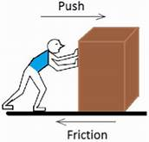
Name: _______________________ # ____ section: __________
Target: We will examine how friction affects the amount of force needed to move an object.
After listening to your classmates, we will agree on different surfaces to test. Please list your top two surfaces choices here: (your teacher will assign you one of these)
- _________________________________
- _________________________________
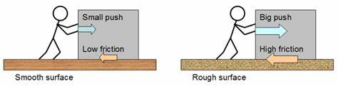
Possible surface modifications
What are some other surfaces besides the plastic mat that you could use as a test surface?
*
*
*
*
*
Learning Check – be ready to share in whole group after a small group discussion:
- What happens when two forces push on an object from opposite directions and one force is larger than the other? What if the forces are equal?
- Are there times when a force is applied and in object doesn’t move? Explain
- What is friction? How does friction affect the force needed to move an object?
- When we completed Pushes and pulls A, what two surfaces were interacting to cause friction?
- If we used a different surface than a plastic mat, how would that affect the force of friction?

