1.2 Day two Reading in Science: The Discovery of Friction

Name: _______________________ #:______ Section: ____________________
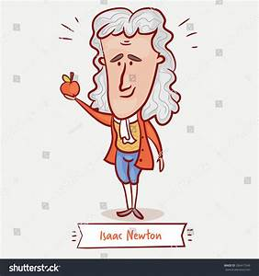
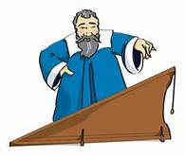
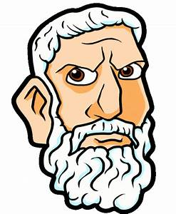

Who? (What Scientist) | When? | What? Did they do that earned them a spot in your science book.
Aristotle
Galileo
Newton
Newton’s Law | In My Own Words – What does this mean?
- Objects at rest, stay at rest and objects in motion stay in motion, unless acted upon by an outside force.
- The acceleration of an object is directly proportional to the force on the object
- For every action (force) there is an equal and opposite reaction.

Finally, answer these questions found at the end of the article on page 14 in your resource book.
- How does the texture of a surface affect friction? ______________________________________________________________________________________________________________________________________________________________________________
- What might happen if you tried to walk across the room and there was no friction? ______________________________________________________________________________________________________________________________________________________________________________
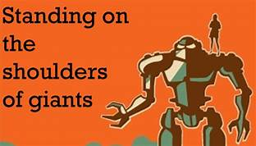
- What do you think Newton meant when he said, “If I have seen further (than most people), it is by standing on the shoulders of giants”? Can you think of another example when someone famous has “stood on the shoulders of giants?” _________________________________________________________________________________________________________________________________________________________________________________________________________________________________________________________________________________________________________________________________________________________________________________________________________________________________________________________________________________________________________________________________________________________________________________________________________________________________

