1.3 Day One Forces in Action
Name:____________________________ #:______ Section: ____________
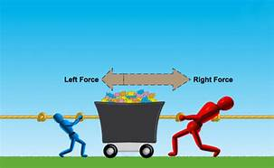
Target: We will explore how multiple forces affect motion in various ways.

Before we get started:
- How can we get this (chair, cart) to move? ___________________________________________________________
- How many newtons do you estimate will be needed? __________ (be sure and note the surface)
Working together as a class, let’s figure this out…
Work space:

How much force was needed to put the cart in motion? ______

- Why didn’t the cart move when less force was applied? ____________________________________________________________________________________________________________________________________________________________________________________________________________________________________________
- What would happen if each student applied the required amount of force on opposite sides? _______________________________________________________
- Watch your teacher use force arrows to explain how different forces can work against each other. Then add your own to the illustration below:
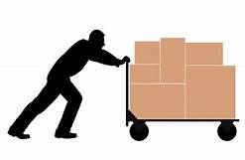

- Please add Net Force to your definitions.
A net force is the total amount of all the forces action on an object.

- Complete the following questions by watching students model the picture and then answering the question that follows:
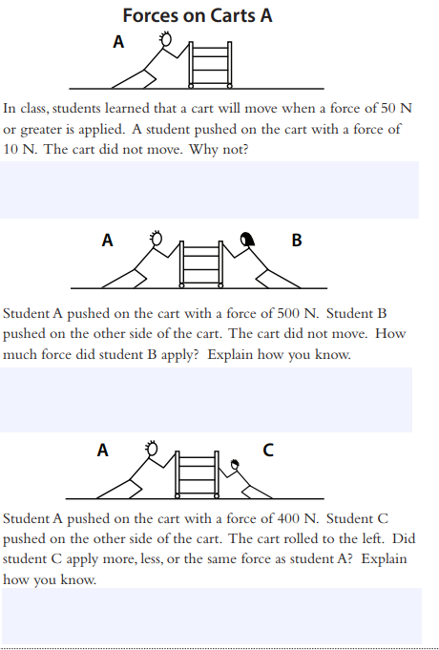

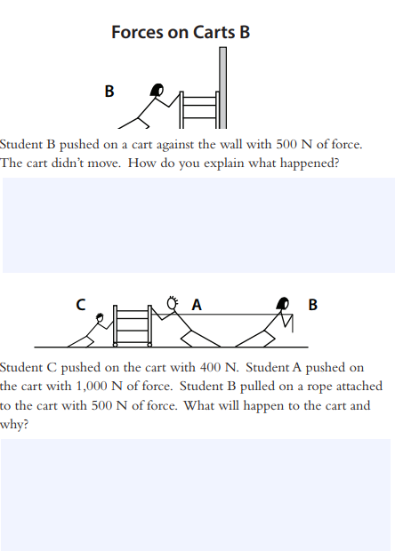

10.) While watching the video “Force,” record which forces are balanced and which are unbalance in the T-chart below
Balance Forces | Unbalanced Forces

