I will develop models to construct explanations about magnetic fields and their properties and interactions.

Name: ______________________________________
Section: ________________
Inducing Magnetism Challenge! – The Paper Clip Chain
- Using a magnet and paper clips, make the longest paper clip chain you can without hooking the paperclips together. Number of paper clips in your chain: _____________________
- What do you think paper clips are made of? ___________________________
- Carefully remove the magnet from the paperclip chain. What happens? ________________________________________________________________________________________________________________________________________________
When you make a paper clip chain, you are inducing magnetism in the steel paperclip. To induce means to make something happen. You have turned your paper clip into a temporary magnet. How long do you think the temporary magnetism will last? Test it with a timer
- How long did your temporary magnet last? __________________________
- Can magnetism attract and repel through materials?
Using a magnet and a paperclip try 5 different materials and record your observations.
Be prepared to discuss your results in 5 minutes.
Materials

Detailed
Observations

- Make a claim about magnetism using your data from the table above. ________________________________________________________________________________________________________________________________________________________________________________________________________________________

- Watch a chair demonstration performed by your teacher. In your own words, describe what you think is happening. Use information from your data table from #5 to help you if you get stuck. ________________________________________________________________________________________________________________________________________________________________________________________________________________________
- What force is keeping the paper clip in the air? __________________________________
- What force pulls the paper clip towards Earth? __________________________________
Magnets can attract iron from a distance and through materials, because magnets are surrounded by an invisible magnetic field that extends out from their poles. This force field is a region where the magnetic forces can be observed or detected. The magnet exerts a force that acts right through wood, paper, plastic and air.
- Brainstorm - What tools or substances could we use to detect a magnetic field? _______________________________________________________________________
Magnetic Field Mystery
Can you figure out where 2 magnets are taped inside a box without looking inside?
Can you figure out the shape of each magnet and which direction it is going?
Can you find the north and south pole of each magnet?
Materials you may use-
- Paper clips
- Iron filings
- Compass
- Doughnut shaped magnet
Rules-
- DO NOT OPEN THE BOX
- Be gentle and respectful with all supplies.

Describe you test. | Describe the results with detailed observations.

Draw and label an accurate model of the box and where you think the two magnets are located in the box, the shape of the magnets and the north and south pole of each of the magnets. Be sure to include any of the tools you used in the model as well.
Magnetic Field Mystery – Analyze the data you collected.
What were the strengths and limitation of each of your tools?
Tool | Compass | Iron Filings | Doughnut Magnet | Paper Clip
Strength
Limitation
(Weakness)

- Why Do you think the iron fillings made those interesting patterns? Explain: __________________________________________________________________________________________________________________________________
- Open your box! Was your group correct on the location of your magnets? Did you solve the mystery?? ______________________
- Explain what your group did right or what your group should have improved. ___________________________________________________________________________________________________________________________________________________________________________________________________
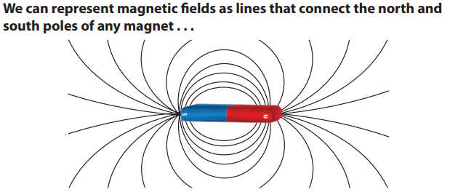
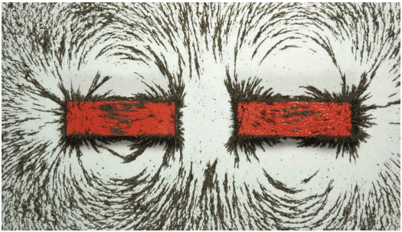
Iron filings are very small pieces of iron, so they move very easily in response to magnetic forces. As a result, the patterns they form help us identify magnetic fields. A magnetic field is invisible, but we can make inferences about its characteristics by looking at the pattern of iron filings.

- What pattern do you notice with magnetic fields? __________________________________________________________________________________________________________________________________
- Think back to your teacher’s chair demonstration. Can you explain why the paper clip “floated” using scientific vocabulary? __________________________________________________________________________________________________________________________________
- Place a magnet under this paper on planet Earth A so that the north pole is at the north pole and the south pole is at the south pole. Use the plastic bag with the iron filings and shake it around over the Earth. (Keeping all filings in the bag!!!!) Draw the pattern you observe on the Earth B.
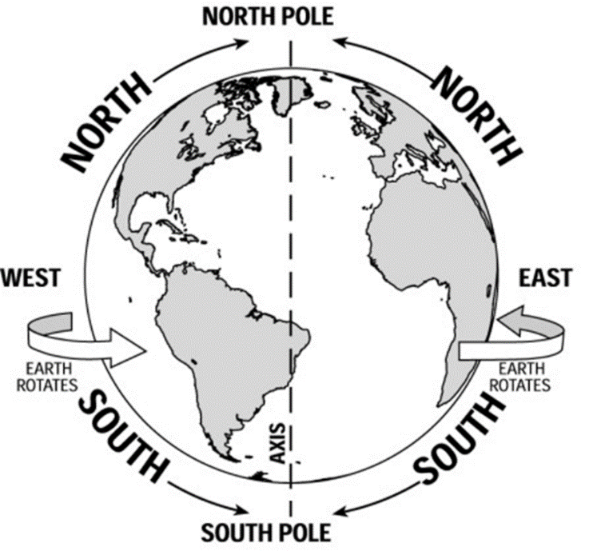
A
B
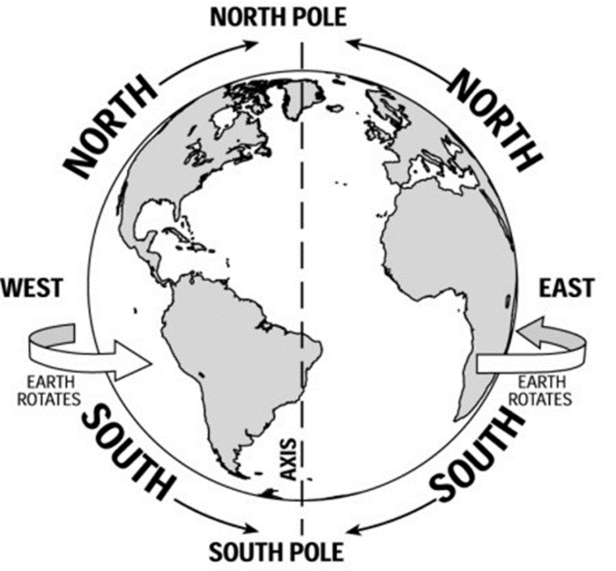

- Watch a Magnetism video clip. Using evidence from our activities and the video explain this scenario – If you put something like a piece of cardboard between a magnet and an iron nail, the magnet still holds the nail in place, even though the magnet is not touching the nail. ___________________________________________________________________________________________________________________________________________________________________________________________________

- Add the following words to your vocabulary – Magnetism, Magnetic Field, Inducing Magnetism, Temporary Magnet.

- Watch Bill Nye, Magnetism and complete the quiz

