3.1 Building a Circuit – Day one
Name: ______________________________________ #:______ Section: _________________
Target: We will determine a procedure for constructing a circuit using only 3 components.

Before we begin: D-cell “batteries “are a safe source of potential chemical energy. It has only 1.5 volts of electricity compared with the 110 to 120 volts in a wall socket. It has less than 1 amp, compared with the 30 amps in a wall socket. In short, your battery is pretty safe, wall sockets and other sources of electricity are not! If you detect heat in your wire or battery, please let your teacher know!!!!
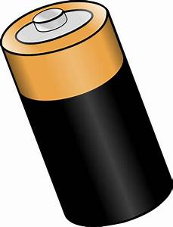
- Please label the D cell battery below and add the definition of battery to your vocabulary sheet using the glossary at the back of your science text or your teacher’s power point if it is available. This should take you no more than 3 minutes
D cell battery

Question: How can you get energy from this source, the D cell, to a lightbulb? (How can you complete an electric circuit?

- Hypothesis: (be as specific as you can) ______________________________________________________________________________________________________________________________________________________________________________________________________________________________________________________________________________

Materials per 2 students:
- 1 lightbulb
- 1 battery
- 2 wires

- Procedure: You will have roughly 5 minutes to try and light your lightbulb using the materials above. The procedure is up to you! Describe what you did below once you discovered it!
____________________________________________________________________________________________________________________________________________________________________________________________________________________________________________________________________________________________________________________________________________________________
- Your turn to teach: Direct Mrs. Yurek or Mrs. Martin how to build a complete circuit using the “Lighting a bulb” activity on Foss online.

- Now draw your own diagram of your circuit below. Be sure to label it carefully.

- Now, add circuit, component, and energy transfer to your vocabulary sheet using your teacher’s PowerPoint or your book’s glossary.

- Predict which of the circuit diagrams below will work to light the bulb. Then, try it with your available materials.
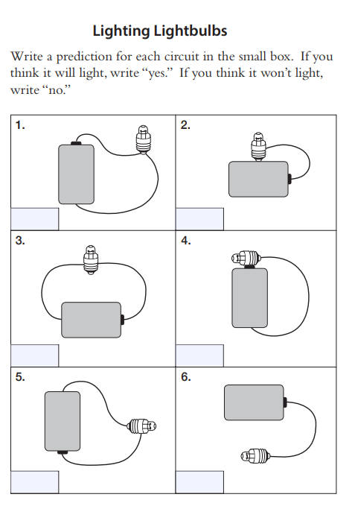
If time allows, try each of the above circuits to see if your predictions were correct. Alternatively, your teacher will go over them with you.

