3.1 Day one continued Building a Circuit
Name: _____________________________ #_____ Date: _________________

- Using your text book or your teacher’s PowerPoint, define: Electric Circuit, Components, contact points, and insulation and filament.

- Look back at diagram 5 from yesterday and label these parts along with arrows to trace the path taken by the electricity from the negative end of the D-cell through the wire to one contact point on the base of the lightbulb, through the filament, to the second contact point.

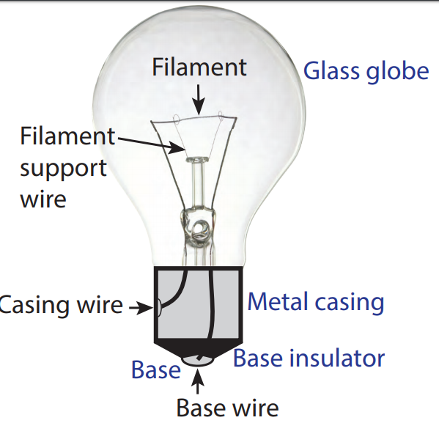
- Study the Diagram below of the Incandescent Lightbulb:

- 5 minute challenge: Can you get a lightbulb to light with just one wire? Try.
Looking at yesterday’s circuits, what system does it look like? # _________

READ pages 25 – 30, Circuitry and Light bulbs, from your science book. Then answer the questions below.

- Where does Electric Current come from? ________________________________________________________________________
- Draw and Label the complete closed circuit on page 26

- Describe the energy flow through the circuit.
________________________________________________________________________________________________________________________________________________________________________________________________________________________
- What happens when the pathway is incomplete? Why?
________________________________________________________________________________________________________________________________________________
- Why must the wires touch the contact points to make the light bulb light up? ________________________________________________________________________________________________________________________________________________
- The wires and contact points are ________________________ that electricity can flow through. The plastic material coating the wire is an ______________________________.
- Lightbulbs are examples of ___________________. What did people use for light before light bulbs? ________________________________________________________________________________________________________________________________________________

- How does the lightbulb produce light? Use the picture on page 27 and the paragraph above it to help write your detailed answer. ________________________________________________________________________________________________________________________________________________________________________________________________________________________________________________________________________________________________
- What is an incandescent lightbulb? ________________________________________________________________________________________________________________________________________________
- Describe the process of how Edison discovered what type of material would work best as a filament. ________________________________________________________________________________________________________________________________________________
- List and describe 3 lamps used today that have replaced the incandescent light bulb.
- __________________________________________________________________________________________________________________________________________
- __________________________________________________________________________________________________________________________________________
- __________________________________________________________________________________________________________________________________________
- Why are LEDs better than the old lighting technology? ________________________________________________________________________________________________________________________________________________

