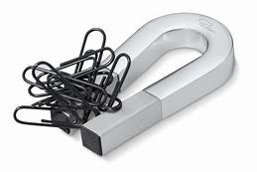
Magnetism:
This must be completed and signed in order to be eligible corrections points – whichever are available (Mrs. Yurek may let you correct your test for less points if you don’t return this.)
Completion date: _________
Signature Date:
Quiz Date:__________
Name: ____________________
Parent Signature: _______________________
(Or AC LAB TEACHER)
Check off the bullet points you have done to prepare for your quiz please. You should do a minimum of 3 before asking for a signature from a guardian or Ac Lab teacher and 1 of them must be to answer the questions on the back.
- Practice Vocabulary Words – Pay special attention to Magnetic Fields, temporary and permanent magnets, Potential and kinetic energy
- Reread science articles - Your teacher has copies if you need them
- Make sure your work is complete for all of the Magnetism Unit – It is labeled EM 2.1 all the way through EM 2. 3 - Day 3. If you were absent, be sure you read through the lab activities, so you know what you missed!
- Watch (or re -watch) Bill Nye – “Magnetism” online
- Ask your teacher questions about any of the topics that have you puzzled

- MUST DO: Answer these 4 important guiding questions on the back:
- What are 3 properties of magnets?
- What happens to the particles in a magnet when a magnet is broken into smaller and smaller pieces?
- What is a magnetic field and how can it be detected?
- What factors affect the force of attraction between magnets?
- How did the paper clip float? What forces were at play?

